AIT 524: Weekly Assignment 02
Tanmoy Chowdhury
George Mason University

Author Note
This task is being submitted as an assignment task for the course ‘Database Management Essential’ offered in Sprig 2018. For any kind of inquiry, feel free to contact at tchowdh6@masonlive.gmu.edu.

Online Drill
This is a website for coaching soccer. We know soccer is not only a 90 minutes game. It needs lot of dedication and technique by individual and by teamwork. This website will contain the motion pictures on drill in different categories. It would contain subscriber at different stages. There would be specific drill set based on the user’s categories.

Necessity of database for this online-drill company
First, this website contains subscriber with different skill set. A player can register for different type as like Goal-keeper, defense, Stricker. Every type has three skill levels as like beginner, intermediate and expert. Moreover, it has lot of motion pictures which are categorized in different panel. It would become messy if it is not organized in a database.

Business Requirements:
The goal of this website is to provide training for the players. A player can hesitate at the very beginning level about his playing position. As like, a player can be interested in either goal-keeper or defense or striker. Again, a player can be interested in all three types. Every type consists of three different level as like beginner, intermediate, and expert level. For better understanding the scenario, think about a player ‘John’ of age 14. This player can be enrolled as Goal-keeper Beginner Level, Defense Expert Level and Striker Intermediate level simultaneously.
For every category of playing, there would be drill set for dribbling, passing and shooting. For instance, John has already enrolled for Goal-Keeper Beginner Level. This category can be consisting of 2 dribbling drills, 1 passing drills and 5 shooting drills.

In a summery, a player can enroll among 9 categories (Goal-Keeper, Defense, Stricker with Beginner, Intermediate, Expert level) as much as he wants. Every category consists of drill from 3 sets (Dribbling, Passing, Shooting). A drill can be only one type either dribbling or passing or shooting. One drill cannot be part of two different sets.
Based on the business scenario, this website would contain many entities. I hope to come up with a perfect set of entities though out this course by brainstorming more and more. As an initiative step, I have figured out four entities. They are Player, Category, Drill and PlayerCatDrill.
Entities of the system
In previous paragraph I have discussed the business scenario and the cause of choosing the entities. If we want to have a detail version of the entities, then we can end-up as like following:
PLAYER:
This entity is the very beginning step of this web for user-interaction. A user will open his account. Every player will possess an unique id. He can choose one or more category id among those 9 categories. He will not be allowed to choose other than those.
- player_id: A unique id choose by user. It would be VARCHAR. Maximum 10 character will be allowed.
- email: Mandatory attribute as it is necessary to contact with player. Type: VHARCHAR.
- age: Number type

CATEGORY:
Every category would have id (1~9). For more detail description it would contain the attribute player_type and player_level. Moreover, it would also contain player_id and drill_id.
- category_id: (1~9) (Category Chart has been attached here)
- player_type: (Goalkeeper/Defense/Stricker)
- player_level: (Beginner/Intermediate/Expert)

1 | Goalkeeper-Beginner
2 | Goalkeeper-Intermediate
3 | Goalkeeper-Expert
4 | Defense-Beginner
5 | Defense -Intermediate
6 | Defense -Expert
7 | Striker-Beginner
8 | Striker -Intermediate
9 | Striker -Expert
Table 01: Category table
DRILL:
For drill, it should have unique id and type. It will also have duration of every drill in seconds.
- drill_id: VARCHAR (10)
- drill_type: (Dribbling/Passing/Shooting)
- drill_duration: number

PLAYERCATDRILL:
It is very difficult to implement many-to-many relationship in case of relational database. So, for making the relations among those three entities this PLAYCATDRILL entity is necessary. It has three attributes whose is not only as primary key but also as foreign key.
- player_id: VARCHAR
- category_id: (1~9)
- drill_id: VARCHAR

Relationship
I would like to depict the relationship in a table with evaluation.
Entity 1 | Entity 2 | Relationship | Cause
PLAYER | CATEGORY | Many-to-Many | A player can be enrolled in many categories again one category can contain many players
PLAYER | DRILL | Many-to-Many | A player can practice many drills and one drill can contain many players
DRILL | CATEGORY | Many-to-Many | Every category is built with drill set of many drills. Similarly, every drill can be part of many categories.
PLAYER/CATEGORY/DRILL | PLAYERCATDRILL | One-to-Many | One instance from any of these three entities (PLAYER/CATEGORY/DRILL) is related to many instances of PLAYCATDRILL entity.
Table 02: Entity Relationship
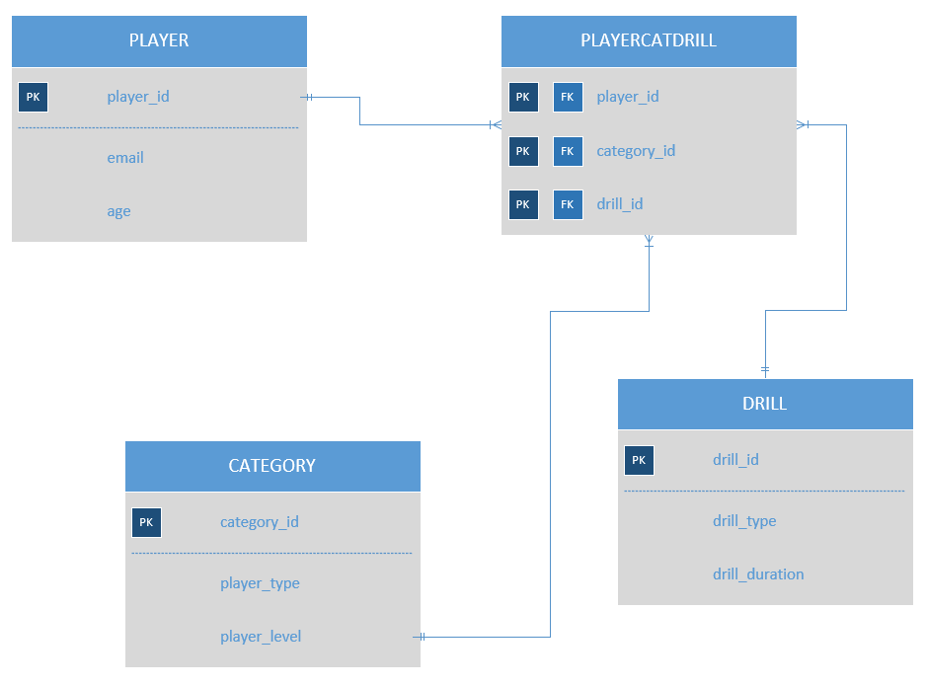
Figure 01: Entity Relationship Diagram
User of Database
As it is a web application it can have three types of user.
App-User: They are the end user of this system. But an immutable design will be applied for them so that they cannot change any data. They can only use the online drill for training purpose.
App-Developer: They are responsible for making the interaction between end-user and the system database. They will develop the program so that user can access the database and use the data. But this App-Developer are not allowed to modify the schema.
Database-Administrator: They have the rights to change the data. This type of account cannot connect from the application. They are the developer account. They can do everything including changing the schema.

DBMS Architecture
I chose three types of user for this system. And there are many business logics based on the player’s category. Everybody is not allowed to access all the drills. Players are allowed to access specific drill based on their enrolled categories. So, for maintaining the business logic we need to apply mid layer between end user and the database. So, our architecture would be a three-tier architecture. Where App-user are the client and Web-server, or application developed by the App-developer would be the mid layer and Database server would be the last layer of this system. I do not prefer to give access the client directly to the data as there is many logics involves. So, I think three-layer architecture is better than others.

References
Elmasri, R., Navathe, S. B. (2016). Database system concepts and architecture in M. J. Horton, Fundamentals of Database Systems (7th ed., pp 31-56) : Pearson.

